**UNIVERSITY OF CALCUTTA  
 DEPARTMENT OF COMPUTER SCIENCE & ENGINEERING**

**EMPLOYEE LEAVE MANAGEMENT SYSTEM**

**Submitted by:  
 Group 7  
  
 Arpan Mondal (Roll - 02)  
 Sougata Patra (Roll - 25)  
 Puja Sarkar (Roll - 10)**

**Use-Case Diagram:**

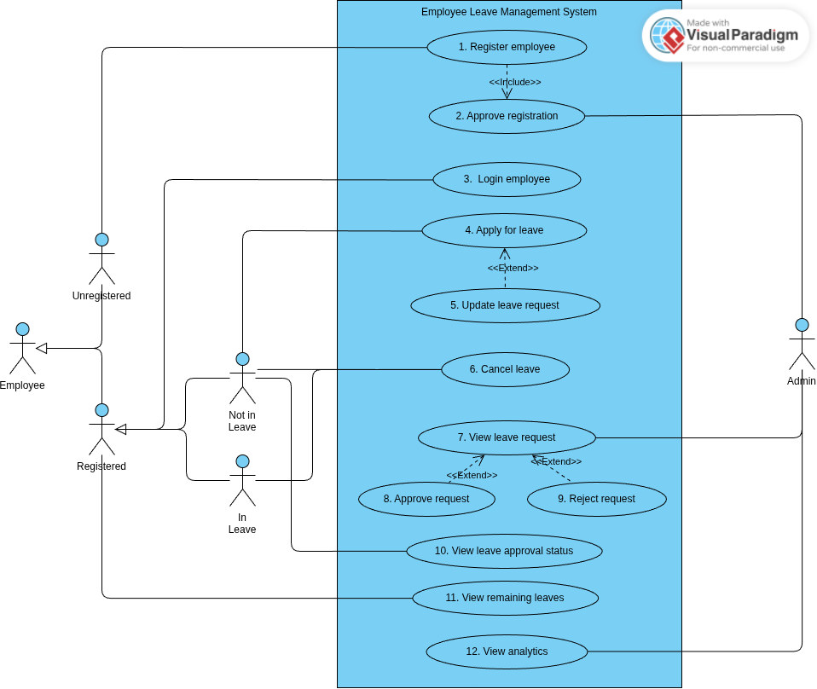

**Actors:**

**1.Employee:**

**Represents a general user of the system who wants to manage their leaves. This actor can either be registered or unregistered in the system.**

**2.Unregistered Employee:**

**An employee who has not yet registered in the system. Their primary interaction is to register themselves for future use of the system.**

**3.Registered Employee:**

**An employee who has already registered and can log in, apply for leave, view leave status, and modify leave requests.**

**4.Employee(Not in Leave):**

**A registered employee who is currently not on leave. They can apply for a new leave request or continue their normal activities in the system.**

**5.Employee(In Leave):**

**A registered employee who is currently on leave. Their status reflects an ongoing leave period, and they may monitor or modify their leave request.**

**6.Admin:**

**The administrator of the system. The admin verifies employee registrations, views leave requests, and decides whether to approve or reject them.**

**Use-Cases:**

**1.Register Employee:**

**An unregistered employee provides personal and professional details to create an account in the system. The process includes filling out required information such as name, employee ID, department, and contact details. Once submitted, the request is stored in the system and forwarded to the admin for verification. The registration remains inactive until approved. This use case ensures that only valid employees can access the leave management features, preventing unauthorized users from entering the system. Successful registration is the first step for an employee to become an active user and utilize other system functionalities.**

**2.Approve Registration:**

**The admin verifies and approves registration requests submitted by employees. This includes validating employee ID, designation, and department details. If the information is correct and matches organizational records, the registration is approved, and the employee becomes an active user in the system. If invalid, the admin may reject or request corrections. This use case ensures system security by preventing unauthorized individuals from gaining access. Approval of registration officially grants employees access to features like applying for leave, modifying leave requests, or checking their status. Thus, it serves as a control mechanism to authenticate genuine users.**

**3.Login Employee:**

**A registered employee logs into the system by entering their credentials, usually consisting of a username and password. The system validates these credentials against stored data to ensure security. Only upon successful verification is access granted. Logging in allows employees to perform actions like applying for leave, modifying leave requests, and checking status. This use case provides authentication and ensures that each employee’s data remains private. It forms the entry point for most employee-related operations in the leave management system. Failed login attempts may be handled by notifying the employee or blocking repeated unauthorized attempts.**

**4.Apply for leave:**

**Employees who are not currently on leave can request a new leave by submitting details such as the start date, end date, type of leave (casual, sick, earned), and reason for leave. The system stores the application and sends it to the admin for further action. Employees can apply for multiple types of leave depending on their organization’s policies. The application remains in a pending state until reviewed by the admin. This feature allows employees to formally request time off while ensuring the organization maintains proper leave records.**

**5. Update Leave Request:**

**Employees can modify an already submitted leave application before the admin takes action. Updates may include changing the leave dates, type of leave, or reason for absence. The system records the modifications and resubmits the updated request for admin approval. This feature reduces the need to cancel and reapply, saving time for employees and reducing administrative workload. It provides flexibility, ensuring employees can correct mistakes or adjust plans. This use case improves accuracy in records and ensures that only the most recent request is considered during the approval process, thereby improving efficiency and reducing confusion.**

**6.Cancel Leave:**

**If an employee no longer needs the leave they had requested or already had approved, they can cancel it through the system. The cancellation request is updated in the records, and the admin is notified. In case the leave had been approved, the system automatically restores the canceled days to the employee’s leave balance. This use case ensures that the system always maintains accurate and up-to-date information about employee availability. Canceling leave provides flexibility for employees who may change their plans and helps admins manage organizational staffing more effectively without scheduling conflicts or errors.**

**7.View leave request:**

**Admins can access all pending and past leave requests submitted by employees. Each request includes critical details like employee name, leave period, type of leave, and reason. This functionality enables admins to thoroughly evaluate applications before making a decision. By centralizing requests, the system ensures no application is overlooked. The admin can approve or reject pending requests and the processed requests are also stored as records.**

**8.Approve Request:**

**When an employee’s leave request is found to be valid, the admin approves it. Approval is typically based on factors such as leave balance, organizational requirements, and the justification provided. Once approved, the employee’s leave status is updated in the system, and the employee is notified. Approved leave is recorded in the system for payroll or HR reporting purposes. Approval ensures employees can officially take time off without administrative confusion.**

**9.Reject Request:**

**If a leave request is not valid the admin may reject it. Upon rejection, the system updates the employee’s leave status and sends them a notification in their portal. The admin may also provide comments or reasons for rejection, offering clarity to the employee. The rejected requests are also stored and can be viewed later but cannot be modified.**

**10.View Leave Approval status:**

**Employees can check the progress of their leave applications at any time. The system displays the status as pending, approved, or rejected. This feature provides transparency and allows employees to plan their work and personal commitments accordingly. If rejected, employees can review the admin’s feedback and reapply if necessary. If approved, the status changes to “In Leave” during the leave period.**

**11.View Remaining Leaves:**

**Employees can check their current leave balance at any time. The system automatically calculates remaining leave days by deducting approved leaves from the total allotted quota. This use case ensures that employees stay informed about their entitlements and plan their leaves accordingly. It also prevents employees from applying for more leaves than they are eligible for. This transparency improves trust and reduces disputes. For the organization, it ensures proper monitoring of employee leave balances, maintaining fairness and consistency in granting leaves across the workforce while supporting better leave planning and workforce management.**

**10.View Analytics:**

**Admins can view summarized reports and analytics related to employee leave data. This includes statistics on leave patterns, department-wise leave distribution, frequently taken leave types, and total absenteeism. Analytics help admins and management identify trends, predict staffing shortages, and make informed decisions for workforce planning. This use case transforms raw leave data into meaningful insights, promoting efficiency and long-term organizational improvements. It also allows admins to spot irregularities, such as excessive leave by certain employees, ensuring fairness. By enabling data-driven decision-making, this functionality adds strategic value to the system beyond daily operations.**